Human analysis of Evidence03.pcap

01/10/2026
Dave Sushames
2026
Contents
Executive summary 1
Tools used 1
Evidence description 1
Device details 2
Findings 2

Executive summary
The evidence03.pcap file contains approximately three minutes of network traffic. On 28 December 2009, between 04:08 and 04:10 UTC, an Apple TV (IP: 192.168.1.10) was used to browse the iTunes movie store. Three searches were made: One search for “hack” which led to the movie Hackers. One search for “sneak” which led to the movie Sneakers. One search for “iknowyourewatchingme”, which suggests that the user believed their network activity was being monitored.

Tools used
Wireshark version 4.6.9
md5sum (for hashing)
Greenshot (for screenshots)

Evidence description
File name | evidence03.pcap
MD5 hash | f8a01fbe84ef960d7cbd793e0c52a6c9
File type | Pcap
File size | 1,537,222 bytes
Packets | 1,778
First packet | Dec 28, 2009 04:08:01.139183000 UTC
Last packet | Dec 28, 2009 04:10:52.310744000 UTC
Duration | ~171 seconds
Before analysis, the evidence file was hashed using MD5 Hashing the file again post-analysis returns the same result, proving that it wasn’t edited in any way during analysis.

Device details
MAC address | 00:25:00:fe:07:c4
IP address | 192.168.1.10
Device type | Apple TV
Software | User-Agent: AppleTV/2.4
DNS server | 4.2.2.1
The only internal IP listed in the capture was 192.168.1.10.

Findings
Figure 1 is a screenshot of the evidence file open in Wireshark, with the filter “http.request.uri contains "incrementalSearch"” applied (1). Displayed in frames 43, 180, 230, and 276 are searches for “h” (2), “ha” (3), “hac” (4), and “hack” (5) being typed in one letter at a time, over the span of 10 seconds.
Figure 1 - Hack search
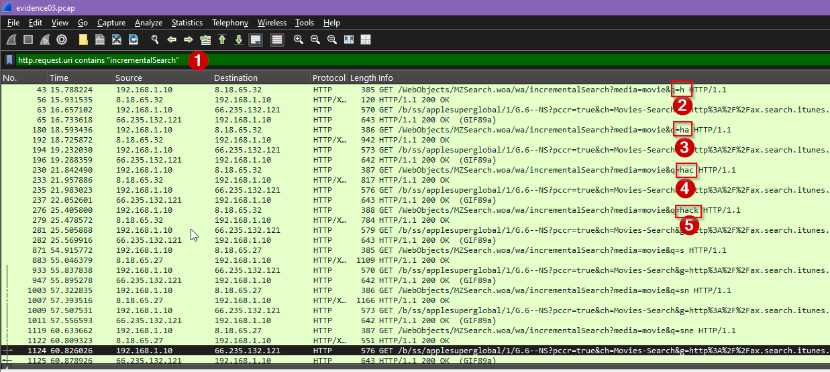

Figure 2 is a screenshot of the Follow HTTP Stream from frame 307. It shows the user-agent AppleTV/2.4 (1) connecting to the host ax.itunes.apple.com (2), and looking at the page for the Hackers movie by Iain Softley (3).
Figure 2 - Follow HTTP to Hackers
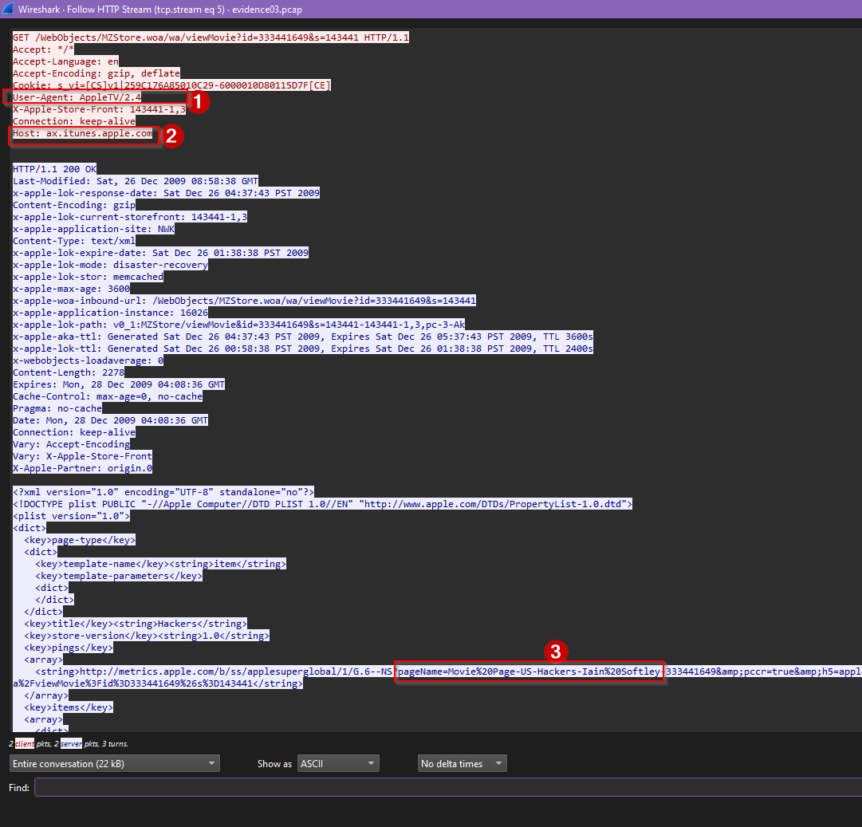
Figure 3 shows a screenshot of the word “sneak” being typed one letter at a time, over the span of ~29 seconds. Frame 1146 includes a typo of “sneb” (1), which is corrected in the next search.
Figure 3 - Sneak search
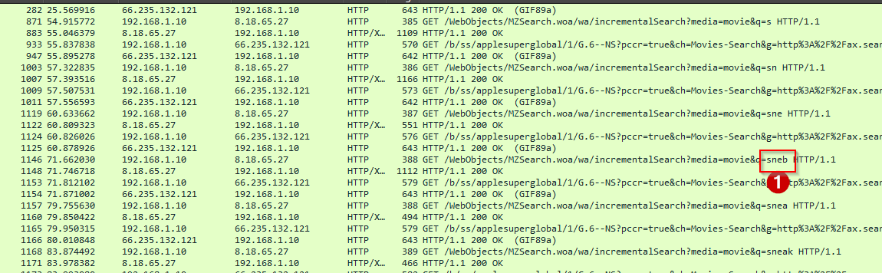
Figure 4 is a screenshot of the Follow HTTP Stream from frame 1181. It shows the user-agent AppleTV/2.4 (1) connecting to the host ax.itunes.apple.com (2), and looking at the page for the Sneakers movie by Phil Alden Robinson (3).

Figure 4 - Follow HTTP to Sneakers
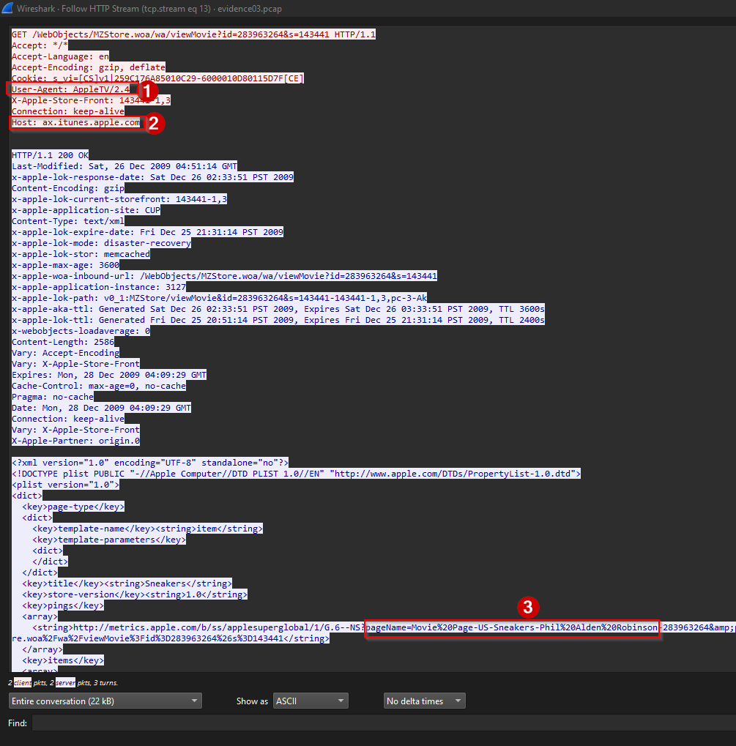
Figure 5 is a screenshot of the phrase “iknowyourewatchingme” (1) being typed from frame 1472 to 1766, over the span of ~60 seconds. This suggests that the user suspects that the network traffic being monitored.
Figure 5 - Iknowyourewatchingme search
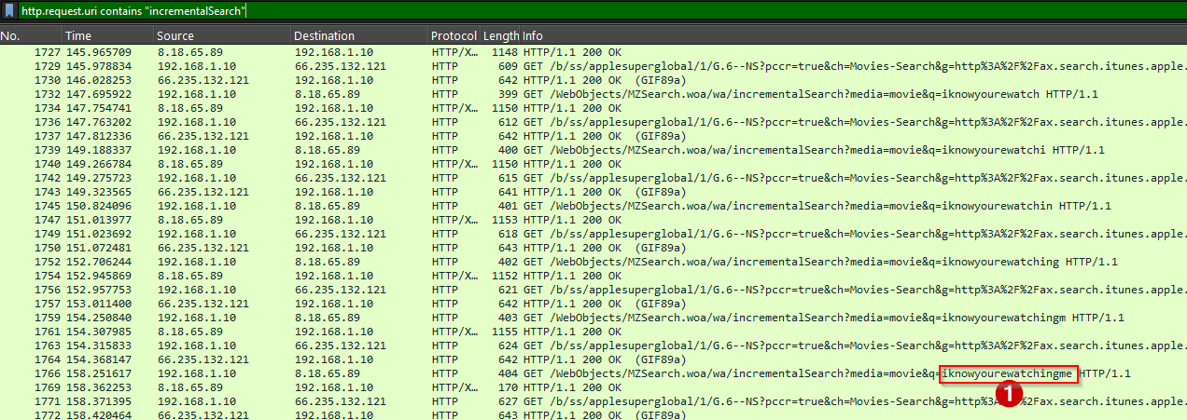
Total time taken: 7 hours 15 minutes.

